**Curator Project**

Student Name

Institution Name

Course Name

Instructor Name

Date

**Exhibition Statement**

When I think of art that is meaningful to me, I think of paintings, photographs, and sculptures that represent my identity and background. I am especially interested in pieces from my culture and heritage, which often portray the struggles and successes of my ancestors. Seeing these pieces reminds me of my journey and how I am connected to the history of where I come from. To change the status quo, visual culture must be more inclusive in its representation of different communities and bring to the forefront the voices and stories of those who have been historically sidelined.

A recent museum exhibition I visited made me think differently about how visual culture can bring people together and tell stories of marginalized groups. The exhibit highlighted the potential of art to be used as a tool for social change, emphasizing the importance of inclusivity and representation in visual culture. The accompanying statement powerfully communicated the message that by amplifying the voices of minority groups and empowering them to tell their stories, society can progress toward unity and justice. This experience demonstrated the power of art to move audiences, further reinforcing my belief that visual culture, when used correctly, is an essential tool for social change.

I searched for images or artworks that reflected my heritage and culture. I have chosen three works that are especially meaningful to me. The first is a painting of a woman in a traditional cultural dress, which reminds me of my identity and heritage. The second is a painting of a landscape, which captures the beauty of nature and triggers memories within me. The last piece is a sculpture that reflects a powerful message of resilience and courage.

**Images**

**First image**

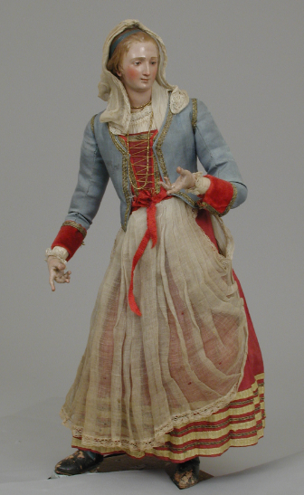

**Artist:** Lorenzo Mosca

**Title:** Woman

**Date:** second half 18h century

**Media:** Polychromed terracotta head and wooden limbs; body of wire wrapped in tow; various fabrics and lace

**Dimensions:** H. 14 5/16 in. (36.3 cm.)

**Wall Text for Image 1**

Lorenzo Mosca's Woman is an example of the Baroque painting style and dates back to the second half of the 18th century. It features a woman draped in a white sheet with a red sash, holding a dove in her right hand. The painting has a bright and vibrant palette, and the subject looks away from the viewer, creating a sense of mystery and intrigue. The Baroque image is known for its dynamic compositions, exaggerated gestures, and heightened emotions, all of which can be found in this painting.

**Second image**

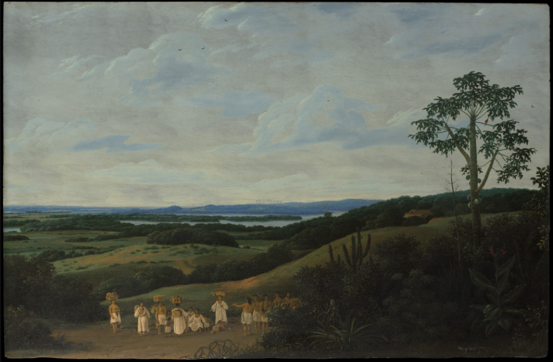

**Title:** A Brazilian Landscape

**Artist:** Frans Post (Dutch, Haarlem 1612–1680 Haarlem)

**Date:** 1650

**Medium:** Oil on wood

**Dimensions:** 24 x 36 in. (61 x 91.4 cm)

**Classification:** Paintings

**Wall Text for Image 2**

Frans Post's painting of A Brazilian Landscape, created in 1650, is a beautiful and expansive portrayal of the area. The painting represents the Dutch exploration of Brazil in the seventeenth century, showing off the lush foliage, the exotic creatures, and the people populating the scene. Post's ability to capture the compelling details of the landscape and its inhabitants is remarkable. He skillfully utilizes light and color to convey this exotic environment, creating a painting that captures the Brazilian landscape superbly and beautifully.

**Third image**

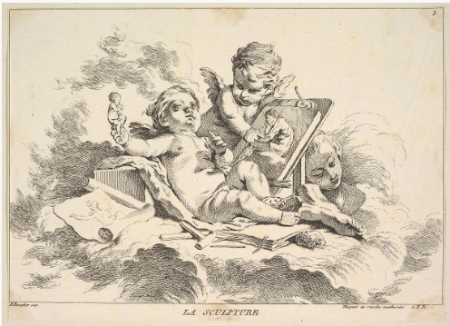

**Title:**Sculpture

**Artist:**Louis Félix de La Rue (French, Paris 1731–1765 Paris)

**Artist:**After François Boucher (French, Paris 1703–1770 Paris)

**Medium:**Etching

**Dimensions:**sheet: 7 13/16 x 10 15/16 in. (19.8 x 27.8 cm)

**Wall Text for Image 3**

Sculpture by Louis Félix de La Rue, after François Boucher, is an etching that speaks to the artistic achievements of the masters of the French Enlightenment period. The artwork is significant, as Boucher's influence on La Rue's works is evident in its delicate details and precise lines. Its composition is complex yet balanced, with the various elements of the scene coming together in a unified design. The features of nature and architecture are carefully arranged, creating a harmonious whole.

As I learn more about visual culture, these images and works of art show me how important it is to represent everyone and not leave anyone out. They also showed me how art could be used for social change. My goal for this exhibit is twofold: to bring together images and artworks that reflect my heritage and culture and to demonstrate the power of visual culture in creating meaningful connections between diverse groups. By weaving together past and present stories, this exhibit aims to capture the beauty of our shared humanity.

**Works Cited**

Rue, Louis Félix de La, and François Boucher. “Sculpture.” *Metmuseum.org*, The Metropolitan Museum of Art, 2022, [www.metmuseum.org/art/collection/search/394727](http://www.metmuseum.org/art/collection/search/394727).

Post, Frans. “A Brazilian Landscape 1650.” *Metmuseum.org*, The Metropolitan Museum of Art, 2022, [www.metmuseum.org/art/collection/search/437323](http://www.metmuseum.org/art/collection/search/437323).

Mosca, Lorenzo. “Woman, Second Half 18th Century.” *Metmuseum.org*, The Metropolitan Museum of Art, 2022, [www.metmuseum.org/art/collection/search/204181](http://www.metmuseum.org/art/collection/search/204181).